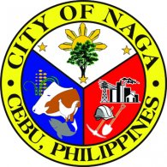
Republic of the Philippines

Province of @prov
@mun
@UTYPE HEALTH OFFICE
HEALTH CERTIFICATE
TO WHOM IT MAY CONCERN:
This is to certify that Mr./Mrs./Ms. @applicant, @age years old, has been examined in this office and was found as of this date to be free from any communicable diseases.
Issued this @day day of @month @year, at Rural Health Unit of @mun, @prov.
Type of Work: |  |  | @occupation
Kind of Business: |  |  |  |  | @kindbus
Name of Establishment: |  |  |  |  |  |  | @busaddress
Business Address: |  |  |  |  |  | @establishment
Immunization: |  |  |  | @immunization
Remarks: |  | @remarks
 |  |  |  |  |  |  |  |  |  | @head
 |  |  |  |  |  |  |  |  |  | @ltype Health Officer
Amt Fee: |  | @amount
OR No.: |  | @orno
Date: |  | @datepaid
@mun, @prov, Philippines

